**VISVESVARAYA TECHNOLOGICAL UNIVERSITY**



MINI PROJECT REPORT ON

**“Multiplexing Multiple Seven Segment Displays ”**

SUBMITTED BY:

**Tanmaya S H (1NH18EC112)**

Under the guidance of

**Ms. Divya Rajan**

Assistant Professor/Senior Assistatant Professor/Associate Professor/Professor, Dept. of ECE, NHCE, Bengaluru.

# C:\Documents and Settings\Students\Local Settings\Temporary Internet Files\Content.Word\download (1).jpg

# NEW HORIZON COLLEGE OF ENGINEERING

(ISO-9001:2000 certified, Accredited by NAAC ‘A’, Autonomous college permanently affiliated to VTU)Outer Ring Road, Panathur Post, Near Marathalli, Bengaluru-560103

NEW HORIZON COLLEGE OF ENGINEERING

## DEPARTMENT OF ELECTRONICS AND COMMUNICATION ENGINEERING



**CERTIFICATE**

Certified that the mini project work entitled “**Multiplexing multiple 7-segment displays**” carried out by **Tanmaya S H (1NH18EC112),** bonafide student of Electronics and Communication Department , New Horizon College of Engineering, Bangalore.

The mini project report has been approved as it satisfies the academic requirements in respect of mini project work prescribed for the said degree.

Mini Project Guide: HOD ECE

Divyarajan Sanjeev Sharma Senior Assistant professor

Department of Electronics and Communication

------------------------- -------------------------

**External Viva**

Name of Examiner Signature with Date

1.

2.

**ACKNOWLEDGEMENT**

The satisfaction that accompany the successful completion of any task would be, but impossible without the mention of the people who made it possible, whose constant guidance and encouragement helped us succeed.

We thank **Dr. Mohan Manghnani**, Chairman of **New Horizon Educational Institution**, for providing necessary infrastructure and creating good environment.

We also record here the constant encouragement and facilities extended to us by **Dr.Manjunatha**, Principal, NHCE and **Dr. Sanjeev Sharma**, Head of the Department of Electronics and Communication Engineering. We extend sincere gratitude to them.

We sincerely acknowledge the encouragement, timely help and guidance to us by our beloved guide **Ms. Divya Rajan** to complete the project within stipulated time successfully.

Finally, a note of thanks to the teaching and non-teaching staff of electronics and communication department for their co-operation extended to us, who helped us directly or indirectly in this successful completion of mini project.

**Tanmaya S H (1NH18EC112)**

**TABLE OF CONTENTS**

ABSTRACT

**CHAPTER 1**

INTRODUCTION…………………………………………………………………………………3

**CHAPTER 2**

LITERATURE SURVEY………………………………………………………………………… 4

**CHAPTER 3**

PROPOSED METHODOLOGY…………………………………………………………………..6

**CHAPTER 4**

PROJECT DESCRIPTION ………………………………………………………………………..9

4.1 HARDWARE DESCRIPTION……………………………………………………………….11

4.2 SOFTWARE DESCRIPTION…………………………………………………………………19

**CHAPTER 5**

RESULTS AND DISCUSSION…………………………………………………………………22

**CHAPTER 6**

CONCLUSION AND FUTURE SCOPE …………………………………………………………27

REFERENCES…………………………………………………………………………………….57

**LIST OF FIGURES**

Fig 4.0

Circuit diagram of Astable mode using IC-555……………………………………………………………………..6

Fig 4.1

Output waveform of circuit shown in the fig4.0 ………………………………………………………..6

Fig 4.2

Circuit diagram of monostable mode using IC-555…………………………………………………………..7

Fig 4.3

Output waveform of circuit shown in the fig 4.2…………………………………………………………….8

Fig 4.4

Circuit diagram of bistable mode using IC-555………………………………………………………………9

Fig 4.5

Output waveform of circuit shown in fig 4.4…………………………………………………………………9

Fig 4.6

Pin diagram of IC-555…………………………………………………………………………………………………..10

Fig 4.7

Circuit diagram of IC-555 timer…………………………………………………………………………………….10

Fig 4.8

Waveform of IC-555……………………………………………………………………………………………………11

Fig 4.9

General block diagram of flip flop…………………………………………………………………………………12

Fig 4.10

Logic diagram of S-R flip flop………………………………………………………………………………………….13

Fig 4.11

Timing diagram of S-R flip flop……………………………………………………………………………………….14

Fig 4.12

Logic diagram of J-K flip flop…………………………………………………………………………………………………14

Fig 4.13

Timing diagram of J-K flip flop………………………………………………………………………………………..15

Fig 4.14

Logic diagram of D flip flop………………………………………………………………………………………………….16

Fig 4.15

Timing diagram of D flip flop………………………………………………………………………………………………16

Fig 4.16

Logic diagram of T flip flop………………………………………………………………………………………………….17

Fig 4.17

Timing diagram of T flip flop…………………………………………………………………………………………………17

Fig 4.18

Asynchronous counter using JK flip flop………………………………………………………………………………..18

Fig 4.19

Logic diagram of a modulo-5 counter……………………………………………………………………………………19

Fig 4.20

Synchronous counter using JK flip flop…………………………………………………………………………………21

Fig 4.21

IC pin diagram of 7476…………………………………………………………………………………………………………22

Fig 4.22

Circuit diagram of 2 bit counter……………………………………………………………………………………………22

Fig 4.23

Waveform of 2 bit counter………………………………………………………………………………………………….23

Fig 4.24

Logic diagram of 2:4 decoder……………………………………………………………………………………………..24

Fig 4.25

Pin diagram of IC-74139……………………………………………………………………………………………………..25

Fig 4.26

Circuit diagram of 2:4 Decoder…………………………………………………………………………………………25

Fig 4.27

Pin diagram of AT28C16………………………………………………………………………………………………………27

Fig 4.28

Block diagram of AT28C16…………………………………………………………………………………………………27

Fig 4.29

Connections given to the EEPROM……………………………………………………………………………………28

Fig 4.30

Common cathode 7 segment display………………………………………………………………………………..30

Fig 4.31

Complete schematic diagram………………………………………………………………………………………….32

Fig 5.0

General picture of the project…………………………………………………………………………………………33

**LIST OF TABLES**

Table 1.0

Truth table of SR flip flop……………………………………………………………………………………………………….13

Table 1.1

Truth table of JK flip flop………………………………………………………………………………………………………..15

Table 1.2

Truth table of D flip flop………………………………………………………………………………………………………..16

Table 1.3

Truth table of T flip flop………………………………………………………………………………………………………….17

Table 1.4

Truth table of asynchronous counter ……………………………………………………………………………………18

Table 1.5

Truth table modulo 5 counter………………………………………………………………………………………………..20

Table 1.6

Truth table of synchronous counter………………………………………………………………………………………21

Table 1.7

Function table of 2:4 decoder ………………………………………………………………………………………………..26

Table 1.8

Pin configurations of AT28C16……………………………………………………………………………………………….27

Table 1.9

Truth table for BCD to seven segment display decoding………………………………………………………………………………………………………………………………..30

**ABSTRACT**

Multiplexing is one of the technique used to connect devices like LEDs for displays or buttons

in a matrix of addressable rows and columns. The advantage of this is simplification of the hardware

due to the reduced number of pins required. Multiplexed displays using seven-segment LEDs are popular due to their low cost and high brightness.7-segment LED displays are used to display digital information .

Each segment consists of one or more than one LED and it can be lit independently of all others to form digit 0 to 9.A limited range of alphabetic characters can also be formed but these are of mixed case .It can be difficult to read. Typically the displays have a common pin for all the LEDs anode or cathodes. Eight pins will suffice for a true seven-segment display whereas nine are required as a decimal point. By multiplexing seven-segment displays the number of pins required to drive the displays are be reduced.

Basically most of the time it’s easier to program a microcontroller to multiplex a 7-segment or a LED

matrix displays One at a time.

There are ways to multiplex the 7-segment and LED displays easily using microcontrollers, but

expensive.So it can be done using external hardware to multiplex the seven segment display by using an

EEPROM, dip switches, decoders, counters (using JK flip flops) and a variable clock circuit (using IC 555).

The binary information can be displayed in the form of decimal using this seven segment display. Its

wide range of applications is in calculators, washing machine, micro-oven, radios, digital clocks,

odometers, clock radio etc.

**CHAPTER 01**

**INTRODUCTION**

Multiplexing is a technique used to connect multiple devices-typically LEDs (for displays) or buttons (for keyboards) in a matrix, controlling one device at a time. The main advantage of multiplexing is simplification of hardware due to the reduced number of pins required.

Multiplexed displays using 7-segment LEDs remain popular due to low cost and high brightness.7-segment LED displays are commonly used to display digital information. Each segment consists of one or more LEDs and can be lit independently of all others to form digit 0 to 9 and letters A to F.

The hardware used for multiplexing by us are a clock(using IC555), counter(using JK flip flop),2:4 decoder, EEPROM, dip switches and four, 7-segment displays.

Each block was built one by one on two breadboards and was combined in the end. Unlike most other displays that use a microcontroller to multiplex, this project uses basic digital circuits such as a clock circuit, asynchronous counter, a 2:4 decoder and an EEPROM to multiplex the seven segment displays.

First the data present in EEPROM is erased and then the 16bit bit valued is stored in EEPROM by programming it and then dip switches are connected to EEPROM to select the value to be read. EEPROM is then connected to seven segment displays. Clock circuit is built using IC555 timer circuit so that it sequences the output display. A small counter is also used to provide required toggling condition.

**CHAPTER 02**

**LITERATURE SURVEY**

|  |  |  |  |
| --- | --- | --- | --- |
| **PAPER NO** | **TITLE** | **AUTHOR AND YEAR OF PUBLICATION** | **OUTCOME** |
| **1.** | Interfacing a Multiplexed seven segment display with the 8086 Microprocessor | Md. Moyeed Abrar  2018 | Helps us understanding  Multiplexing better. |
| **2.** | AT28C16  Datasheet | ATMEL corporations  1998 | To understand the working of EEPROM |
| **3.** | Arduino projects to save the world | Brian Evans  2011 | To program the 2048 addresses of the EEPROM |
| **4.** | LM555 Timer  datasheet | TEXAS Instruments  2015 | Helped us understand the internal working and different modes of the 555 IC. |

**CHAPTER 03**

**PROPOSED METHODOLOGY**

There are many ways to multiplex a 7-segment display, the most popular way is by using a microcontroller. But we are not using it because a microcontroller is quite expensive and overkill (too powerful) for multiplexing just four 7-segment displays.

The bare minimum hardware required to multiplex is used, that is, a clock, a counter, a decoder and an EEPROM. This way, we save a lot on the hardware cost.

Generally seven segment displays are driven individually through separate I/O pins which need 28 I/O pins for 4 seven segment displays. So instead of using 4 EEPROMs for 4 7-segments, just one has been used . The 4 7-segments are connected in parallel and using the clock, counter and decoder circuits, the output display is sequenced one by one.

The EEPROM was programmed for 1’s, 10’s, 100’s and 1000’s place and a decoder was used to select the required outputs.

When counter is at 0 it outputs the number at one’s place, at 1 it outputs the number at ten’s place, at 2 it outputs the number at hundred’s place and at 3 it outputs the thousand’s place.

**CHAPTER 04**

**PROJECT DESCRIPTION**

This project uses an EEPROM along with a few essential circuits like a clock, counter and decoder to multiplex multiple 7-segment displays (in this case four) to display numbers.

The main objective of this project is to help us easily understand and demonstrate others, how multiplexing works and essentially how any display is able to display all its content without a lot of data lines.

Well, to begin with, we researched on multiplexing and found out that it means to control many output pins using a few data and control inputs. Controlling each output one at a time and sequencing through them at a very fast rate that, we humans cannot see it happening and feels as if all of them are controlled simultaneously.

Our project can be broadly classified into 5 blocks:

1. **Clock circuit ( using IC 555)**
2. **2-bit Asynchronous Counter (using JK FF’s IC 7476)**
3. **2:4 Decoder (using IC 74139)**
4. **2 KB EEPROM (CSI AT28C16)**
5. **7-segment displays (Common Cathode- Red)**

**CLOCK CIRCUIT(USING IC 555)**

**DIFFERENT OPERATING MODES OF 555 TIMER:**

The 555 timer is an IC (Integrated circuit) used in variety of pulse generation, oscillator and timer applications. There are three different modes of operations, they are:

1. Astable mode
2. Monostable mode
3. Bistable mode

**1. Astable mode:**

When the circuit is in astable mode it has no stable state, hence the name “astable”. Therefore it acts as an oscillator that generates a square wave. The frequency of the square wave can be varied by varying the values of two resistors and a capacitor connected to the chip. The formulas given below can be used to calculate the length of the output’s off and on cycles with different capacitors and resistors:

toff =0.69 * C1 * (R1*R2)

ton =0.69 *C1 * (R2)

Where,

toff :-length of low output pulse in seconds

ton :-length of high output pulse in seconds

C1:-Capacitance of C1 in farads

R1:- Resistance of R1 in ohms

R2:-Resistance of R2 in ohms

This type of circuit can be used to flash lamps and LEDs .It can also be used to give a mechanism intermittent motion by switching on and off a motor at regular time intervals. It is useful as a clock pulse for digital circuits.

**Circuit diagram:**

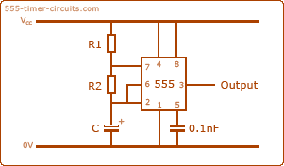

**Figure 4.0**

**Output waveform:**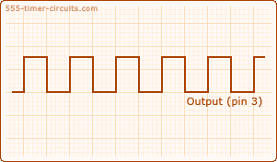

**Figure 4.1**

**2. Monostable mode:**

When the circuit is in monostable mode it produces output as a single pulse of current for a certain length of time. The output of the circuit remains in the low state until the trigger input is given, hence the name ‘monostable’ meaning ‘one stable state’. This circuit is called as one shot circuit.

An example of this kind of circuit is an LED and a push -button. The LED will turn on with one press of the button and then turn off automatically after a pre-determined length of time. The time for which the LED stays on depends on the values of capacitor and resistor connected to the chip (555 timer).The time can be calculated from the below equation:

t=1.1 * R * C

Where, t: length of the electrical output in seconds

R: resistance of the resistor in ohms

C: capacitance of the capacitor in farads

As it is seen from the above equation, the length of the output can be increased by using large values of capacitor or resistor. This circuit can generate pulses from a few micro-seconds to several hours depending on the values of capacitor C and resistor R. The use of very large capacitor values are discouraged because of their wide tolerance limits. This means that their actual value is far from their marked value. Another drawback with such a capacitor is its high leakage current, which may change timing accuracy.

The monostable circuit can be used as a touch switch. It can also be used as servo motor tester, security alarms, tone generation and so on.

**Circuit diagram:**

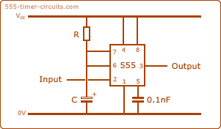

**Figure 4.2**

**Output waveform:**

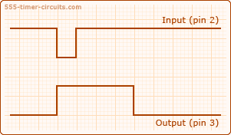

**Figure 4.3**

1. **Bistable mode:**

When the circuit is in bistable mode it acts as a flip flop or Schmitt trigger, hence this mode is also known as a flip flop circuit. A flip flop circuit alternates between 2 stable states. Unlike the astable and monostable modes, bistable mode does not require a capacitor and a resistor to set the timing of the circuit .therefore there is no timing in the circuit .This circuit has only two stable states( i.e., on and off),which is controlled directly by the reset pin and trigger pin respectively.

An example of bistable mode of 555 timer can be demonstrated with an LED and a push button connected to the reset pin and trigger pin LED turns on pressing the trigger button once and it stays on till the reset button is pressed which turns off the LED. By pressing trigger button current is allowed to flow from Vcc to ground (which also causes the voltage at the trigger pin to drop).

This mode is used as storage device in computer memories but they are most excellent as latches and counters. They are also used as frequency dividers, for reversing to the supply to a given circuit at regular time intervals

**Circuit diagram:**

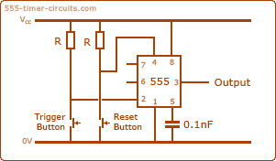

**Figure 4.4**

**Output waveform:**

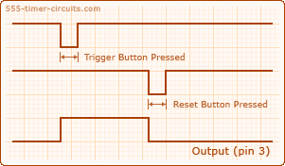

**Figure 4.5**

**PIN DIAGRAM OF IC-555 TIMER:**

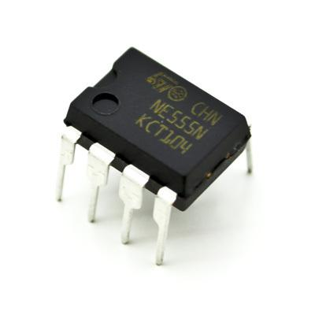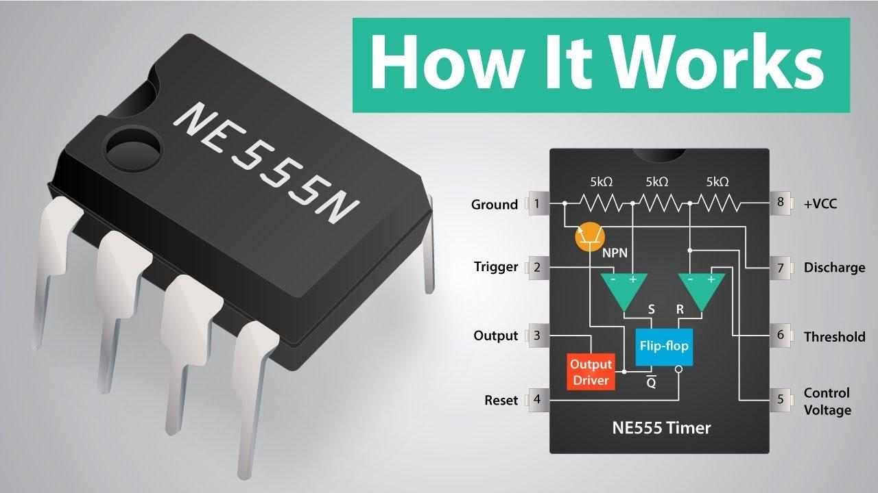

**Figure 4.6**

**Circuit diagram:**

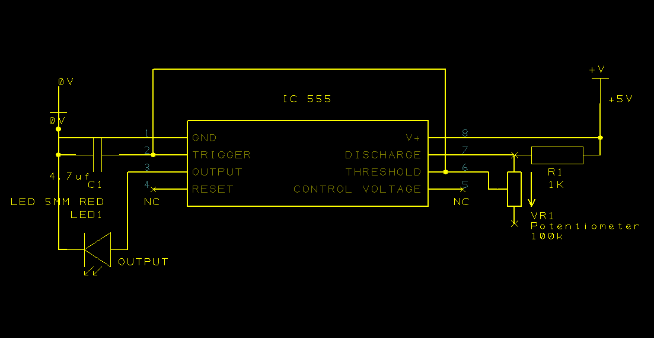

**Figure 4.7**

**Working:**

The IC 555 works as an astable multivibrator in this configuration, that is, it works as an oscillator and generates precise time pulses in a rectangular wave form. The frequency and duty cycle can be accurately controlled by the two resistors and a capacitor. In our case, a 4.7uf capacitor, 1KΩ resistor and a 100KΩ potentiometer has been used with which the speed of our clock can be adjusted from a few Hz to a few KHz.

The exact time period can be calculated using the formula,

*t = (0.693)(R1+R2)(C)*

To be precise, the slowest the clock can get to is 0.33s or 3Hz

( *t1=0.693(101KΩ)(4.7uf)* )and similarly, the fastest clock speed that can be achieved is 307Hz.

In simple words, the charging and discharging of the capacitor through the resistors determine the clock speed. The comparators in the IC 555 switches on and off based on the threshold value and thereby converts the curvy output from the capacitor to a sharp rectangular wave.

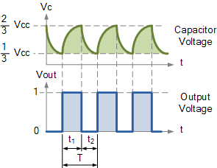

**Figure 4.8**

This way, the clock circuit is built out that can further be used to drive a toggling flip-flop to create an asynchronous 2-bit counter.

**FLIP FLOPS:**

A Flip flop is a circuit that has two stable states that can be used to store binary information. This circuit can be made to change state by applying signals to control inputs. It is the most basic storage element in sequential circuit and also the building block of digital electronics systems used in communications, computers and many other types of systems.

Flip flops are either edge triggered (i.e., synchronous, or clocked) or level triggered (i.e., asynchronous, or transparent). Generally the term ‘Flip -Flop’ refers to a device that is used to store a single bit of data.

**General Block Diagram**:

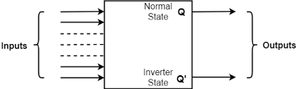

**Figure 4.9**

It can have n number of inputs and has two complementary outputs Q and Q’

TYPES OF FLIP FLOPS:

Flip flops are divided into following types:

1. S-R Flip flop
2. J-K flip flop
3. T flip flop
4. D flip flop

The major differences between these flip flops are the number of inputs they have and how these flip flops alter their states (outputs) according to the inputs. These flip flops can be converted from one form to other form by their characteristic equation and excitation table. Excitation table can be obtained by function table of each flip flop (i.e, by knowing outputs qn,qn+1 the inputs are written down)

**1. S-R flip flop (set -reset):**

**Logic diagram:**

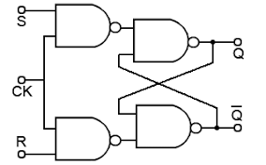

**Figure 4.10**

**Truth Table:**

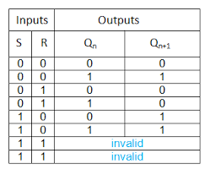

**Table 1.0**

TheS-R Flip flop is made up of two cross coupled NAND gates along with two additional NAND gates and a clock input. Clock input is a clock pulse .The output of first and second nand gates remain at 0 as long as the clock pulse is 0, irrespective of S and R inputs. When clock pulse is 1, information from S and R input lines is passed on to the flip flop.

Case 1: when both S and R inputs are 1, outputs Qn=Qn+1=1 which is not preferred as Q and Q’ should be compliment of each other.

Case 2: When S=1 and R=0 flip flop is in set state.

Case 3: When S=0 and R=1 flip flop is in reset state.

Case 4: when both S=R=1 flip flop holds the previous value as it is in hold state.

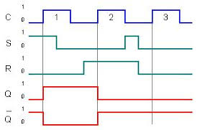**Timing diagram:**

**Figure 4.11**

**2. J-K Flip flop:**

**Logic diagram:** 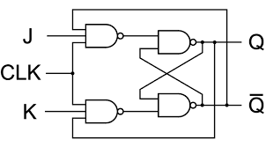

**Figure 4.12**

**Truth table:**

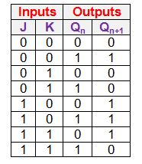

**Table 1.1**

A J-K flip flop is simplification of the S-R flip flop which is used to remove the unpredictable outputs of S-R flip flop when R=S=1.J and K inputs behave as S and R inputs. So when input 1 is applied to both the inputs J and

K the flip flop switches to its complement state J-K Flip flop is designed in such a way that the output Q is given as input to second nand gate along with K input and in similar way output Q’ is given as input to first nand gate along with J input

Case 1: When J=K=0 the Clock has no effect on the output. So the flip flop is in hold state. The output of the flip flop is similar as its previous value because when both J and K are 0, the output of particular nand gate becomes 1

**Timing diagram:**

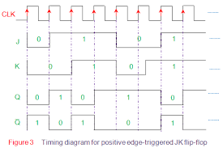

**Figure 4.13**

**3. D Flip flop (Data or Delay ):**

**Logic diagram:**  **TRUTH TABLE:**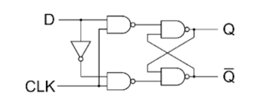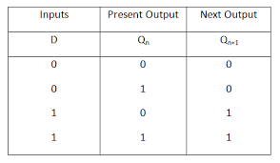

**Figure 4.14**

**Table 1.2**

D Flip is also the simplification of the S-R flip flop which is shown in the above diagram. The input of the D flip flop directly goes to the input s and the complement of D input goes to the R input. It captures the value of the D input at a definite portion of the clock cycle. That captured value becomes the Q output of the flip flop. This flip flop can be viewed as a zero-order hold, or a delay line or as a memory cell.

Most of the D type flip flops are used in ICs have the capability to be forced to the reset or set state similar to S-R Flip flop. These flip flops are very useful as they form the basis for shift registers.

**Timing diagram:**

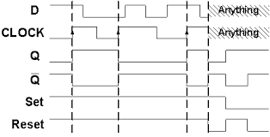

**Figure 4.15**

**4. T Flip flop**:

**Logic diagram: TRUTH TABLE:**

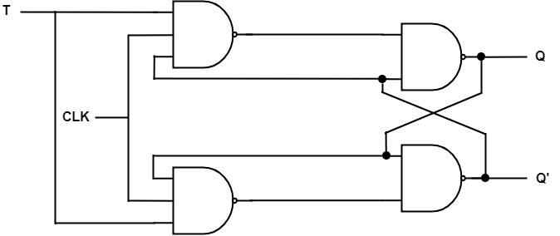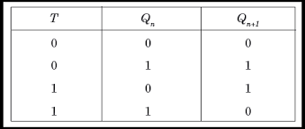

**Figure 4.16 Table 1.3**

The T flip flop (or toggle flip flop) is a single input version of the J-K flip flop in which J and K inputs are shorted. If T input is high, flip flop changes state (‘toggles’).If the T input is low, the flip flop holds the previous value .

**Timing diagram:**

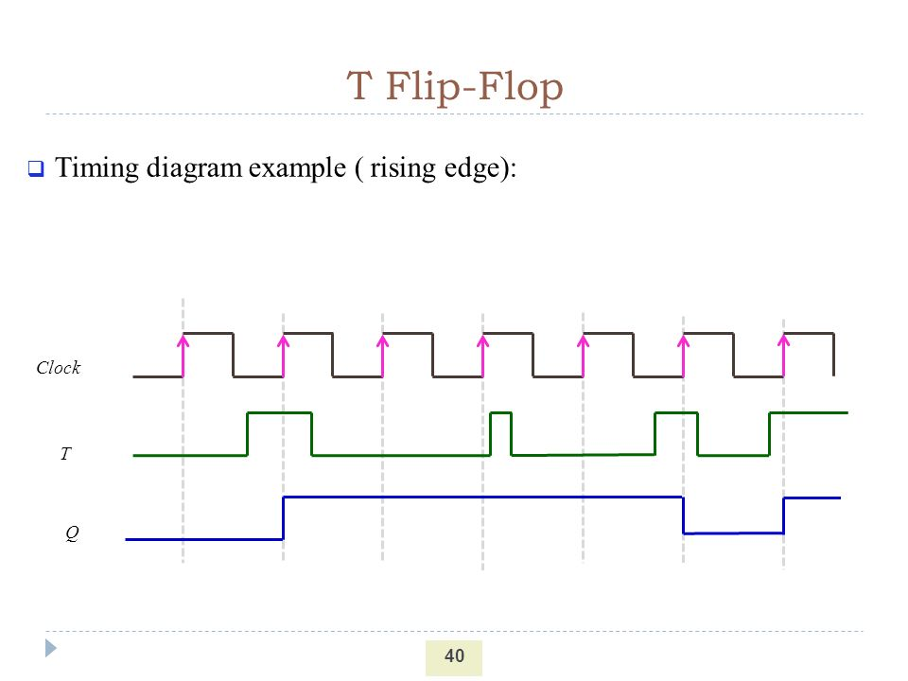

**Figure4.17**

**APPLICATION OF FLIP-FLOP AS A COUNTER:**

Counters are one of the applications of the flip flops which are widely used in digital electronics. Counters are used to count the number of events occurring in specific interval of time. It is basically a sequential circuit that produces specific count sequence .They have memory since they have to remember about past states of the circuit .they are classified into two types:

1. Asynchronous counter
2. Synchronous counter

**1. Asynchronous counter:**

Asynchronous counter also known as ripple counter is formed by connecting complementing flip flops together. The first flip flop is connected with the clock input and the rest of the flip flops are connected to the output of the previous flip flop.

Complementing of flip flops can be created by using J-K flip flops and connecting their inputs together. Here, the clock input is connected only for the first flip-flop. The second flip-flop is triggered by the output of the first flip-flop. The transition of clock input and output Q1 will never occur at the same time. This is known as “Asynchronous operation of counters”. The output of the counter toggles for the positive edge of clock pulse because both the inputs are HIGH (Logic 1).

**Logic diagram: Truth Table:**

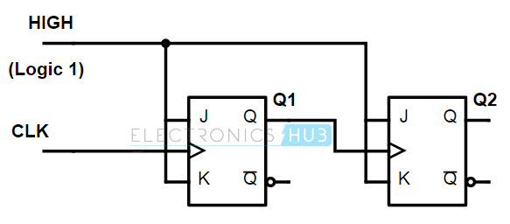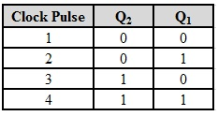

**Figure 4.18 Table 1.4**

Asynchronous Counters can be easily constructed from D-type or T-type flip-flops. Each output in the chain depends on previous flip-flops output. They are also called ripple counters because the data appears o ripple from the output of one flip flop to the input of the next flip-flop. They are implemented using ‘divide –by-n’ counter circuits.

**Modulo-n-counter:**

Modulo –n counter resets after a specified number ‘n’ is reached. They are defined based on number of states that the counter will sequence through before returning back to its original value. Ripple counters are modified to modulo-n-counters by using NAND gates. The number at which ‘reset’ should take place is also given by the NAND gate. When the output of NAND gate is low, the flip-flops resets in the same way the counter output.

A Mod-n counter will require ‘N’ number of flip-flops connected together to count a single data bit and providing 2n different outputs. MOD counters have a modulus value that is an integral power of 2,that is 2,4,8,16 and so on to produce an n-bit counter depending on the number of flip- flops used, and the way they are connected, determining the modulus and type of the counter Example: mod-4 counter

**Modulo-m-counter:**

MOD counters to count any value can be constructed by using one or more external logic gates causing it to skip a few output states .Modulo ’m’ counters do not count all their possible states, but instead count to the ‘m’ value and then return to zero

Considering a modulo-5 counter the counter should reset when it reaches state 101 .The inputs to the NAND gate should be connected to the outputs of the flip-flop 1 and flip- flop 3 (i.e,Q1 and Q3). When the output of both these stages (Q1 and Q3) attains 1,then the output of the NAND gate is 0.This resets the flip-flop.

**Logic diagram of a modulo-5 counter:**

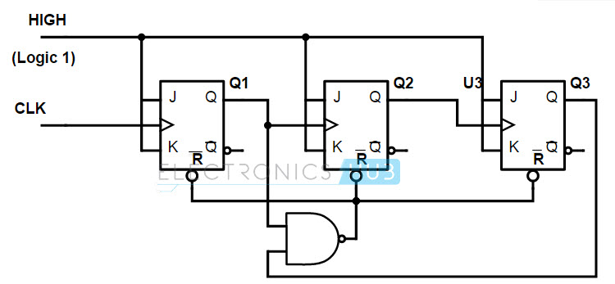

**Figure 4.19**

**Truth table:**

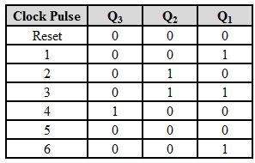

**Table 1.5**

**2. Synchronous Counter:**

In this type of counters, all the flip-flops are connected to the same clock input and all the flip-flops will trigger at the same time. Hence they are also known as “Simultaneous counters”. The only way such counter circuit can be built from J-K flip flops is by connecting all the clock inputs together, so that each Flip- flop receives the exact same clock pulse at same time. This can be done using ‘T’ flip-flop.

Example: 2- bit synchronous counter.

2-Bit synchronous counter:

In this counter, both the flip -flops are connected to same clock input. The output of the first flip-flop acts as the input of the following flip flop.

Initially, the flip-flops are assumed to be in reset state as their outputs are 0( i.e, Q1 and Q2 are 0).When first clock pulse is applied, the first flip flop will toggle as both the inputs of the flip-flop are HIGH(logic 1).For second clock pule both the flip-flops will toggle because the inputs of both the flip-flops are HIGH. When third clock pulse is applied, only first flip-flop will toggle because the input to the flip-flop is 0.

**Logic diagram: Truth table:**

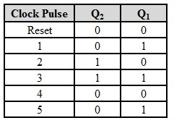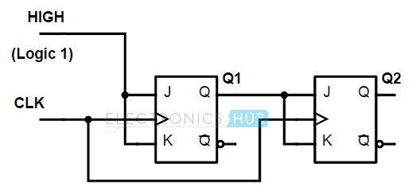

**Figure 4.20**

**Table 1.6**

In case of 3-Bit synchronous counter, the inputs to the third flip-flop is connected to an AND gate that is fed by the outputs of the first and second flip-flop. Similarly, in case of 4-Bit synchronous counter the inputs of fourth flip-flop is connected to an AND gate that is fed by the outputs of first, second and third flip-flops. There are many other types of counters like:

* Ring counter
* BCD counter
* Decade counter
* Up/Down counter
* Frequency counter

**2-BIT ASYNCHRONOUS COUNTER**

**(USING JK FF’S IC 7476)**

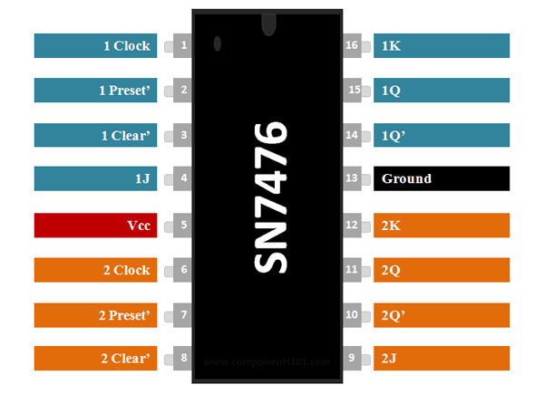

**Figure 4.21**

**Circuit diagram:**

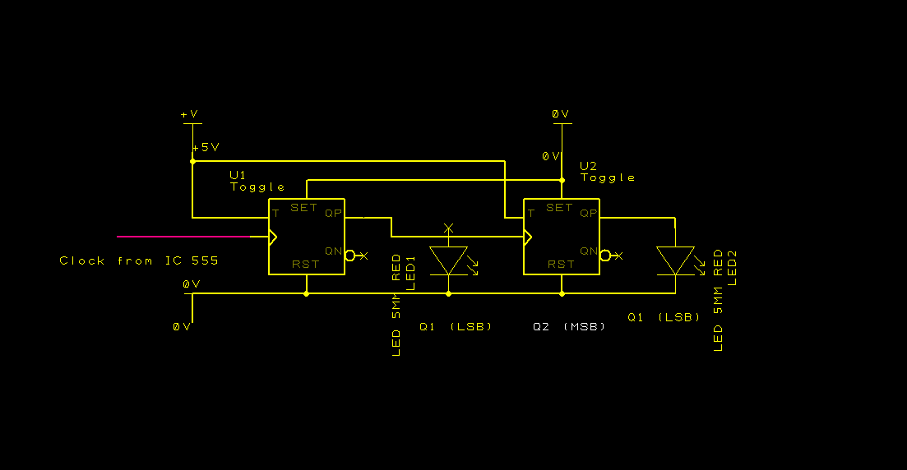

**Figure 4.22**

**Timing diagram:**

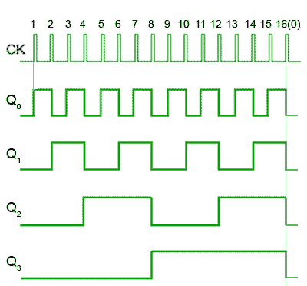

**Figure 4.23**

**Working:**

A JK flip flop is used (as T flip flop) to build an asynchronous 2-bit counter.

When both J and K are shorted and connected to logic 1, the flip-flop goes to toggle mode and its output keeps toggling for every clock pulse. The output of one flip flop is given as the clock to the next flip flop, this way, the second flip flop toggles at half the rate of first flip flop and the circuit works as a counter. The output is taken across Q for both the flip-flops. The reset and set pins are tied low to prevent any accidental set or reset happening in the flip-flops.

Now, this output of the flip-flops is given as a binary input to the decoder as well as the address lines of the EEPROM.

**DECODER:**

Decoder is a combinational logic circuit that converts binary information from the n inputs to a maximum of 2n unique outputs. They have a variety of applications like data multiplexing and data demultiplexing, memory address decoding and seven segment displays.

There are several types of binary decoders, but in all of the cases decoder is an electronic circuit with multiple input and output signals, that converts every unique combination of input states to a specific combination of output.

For example: Output bit number 0 is selected when the integer value 0 is applied to the inputs.

In addition to integer data inputs, some of the decoders also have one or more enable inputs .When the enable is negated, all the decoder outputs are forced to inactive states. In some cases decoders have less than 2n output lines, for which it has at least one output pattern repeated for different input values

Types of decoders:

* 1-of-n decoder:

A 1-of-n binary decoder is a type of decoder that has n output bits. The ‘address’ of the activated output is specified by the integer input value.

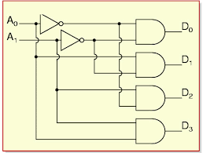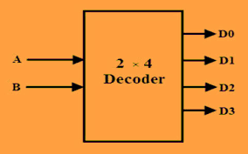

**Figure 4.24**

**2:4 DECODER (USING IC 74139)**

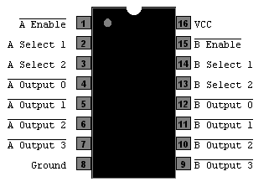

**Figure 4.25**

**Circuit diagram:**

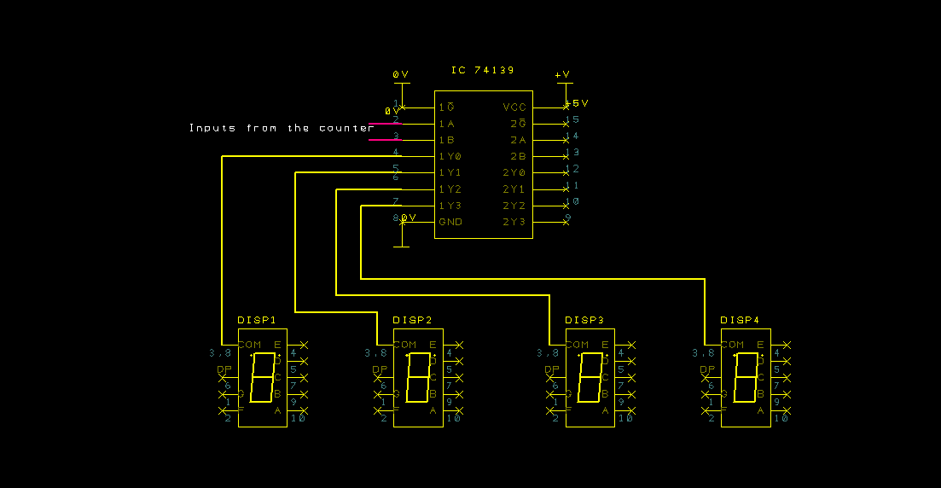

**Figure 4.26**

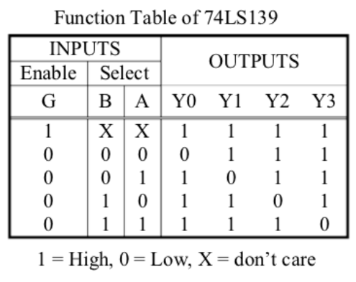

**Table 1.7**

**Working:**

One of the two 2:4 decoders is used in the 74139 IC. This is a example of a 2-to-4 line binary decoder consists of an array of four AND gates. The two binary inputs which are labelled as A and B are decoded into 4 outputs .Each output represents one of the minterms of the two input variables A and B.

The binary inputs A and B determine which output line from Q0 to Q3 is ‘HIGH’ while the remaining outputs are held ‘LOW’ so only 1 output can be active at any one time. Therfore, whichever output line is ‘HIGH’ identifies the binary code at the input. The inputs are given to the decoder from the output of the counter. The decoder provides the ground to each 7-segment display, one at a time during all the four states and repeats the cycle.

**2 KB EEPROM (CSI AT28C16)**

The AT28C16 has 16Kb or 2KB of memory in it. All these data can be accessed using the 11 address lines and data could be stored into or read from the EEPROM using the 8 I/O pins. Other than that, there are supply voltage Vcc, ground GND, write enable WE, output enable OE and chip enable CE pins present in the EEPROM .The chip will be enabled when we give active low to CE. The current through the chip has to be limited by connecting current limiting resistors to the I/O lines. OE must be grounded to be able to read the data in the chip by selecting the address location.

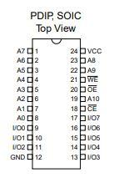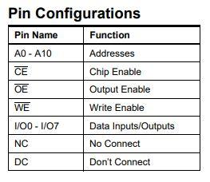

**Figure 4.27 Table 1.8**

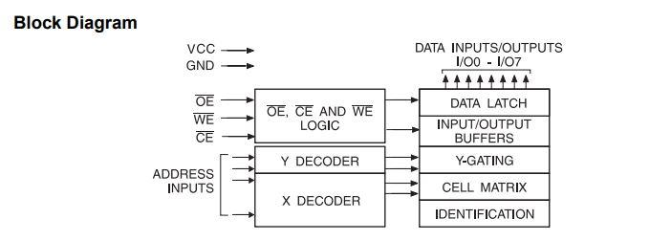

**Figure 4.28**

**Circuit diagram:**

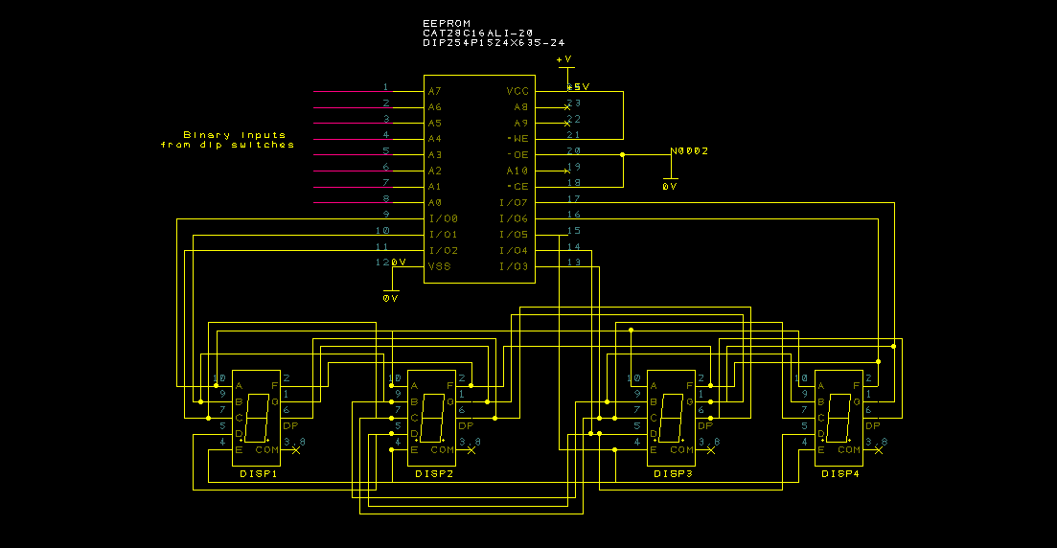

**Figure 4.29**

There are many kinds of ROM chips (read only memory chips) available in the market:

PROM is a Programmable ROM chip in which one can program the chip only once and read it whenever needed.

EPROM (erasable programmable ROM) are the chips in which one can program the data, erase it and use it again. EPROM is a ROM whose data is erased by exposing it to UV light or sunlight. The data can be erased accidentally when the IC comes in the presence of light.

The one that we have used, EEPROM (AT28C16) is the most convenient one whose data can be erased electrically, this way one can erase and re-program the EEPROM over and over again.

The AT28C16 has 16Kb or 2KB of memory in it. All these data can be accessed using the 11 address lines and data could be stored into or read from the EEPROM using the 8 I/O pins. Other than that, there are supply voltage Vcc, ground GND, write enable WE, output enable OE and chip enable CE pins present in the EEPROM .The chip will be enabled when an active low is given to CE. The current through the chip has to be limited by connecting current limiting resistors to the I/O lines. OE must be grounded to be able to read the data in the chip by selecting the address location.

According to the truth table, each address in the EEPROM up to 1024 bits are programmed to display numbers from 0 to 255 by giving input in binary. Each number requires 8 address lines to represent a number and additional 2 data lines to represent the place value of the number. For example, to print 255, the binary input to be given to the EEPROM is 11111111.But, to display 5 in the unit’s place, 5 in the ten’s place, 2 in the hundred’s place and to print nothing in the thousands place, 2 more data lines are required that is taken from the counter to turn on the correct display or in other words, to give the place value.

**Truth table for BCD to 7-segment display decoding:**

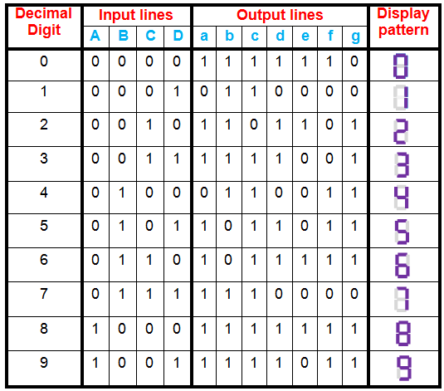

**Table 1.9**

**7-SEGMENT DISPLAYS (COMMON CATHODE- RED)**

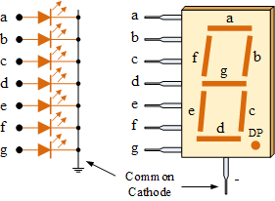

**Figure 4.30**

It is an electronic device which displays the decimal values. There are two types of 7-segment displays: common anode display and common cathode display. A common cathode 7-segment display is preferred, which has 7 LEDs known as segments, an additional dot is also present to display a decimal point. All the segments are placed in a form of eight and a dot beside it. Common cathode displays have all the cathodes of the 8 LEDs connected to the ground and each segment can be controlled by connecting their anodes to Vcc.

A common cathode display is used because the EEPROM works in positive logic and we want each segment to turn on when it is connected to logic 1.

**Putting everything together:**

**ADDITIONAL CIRCUITRY AND COMPONENTS**

* To power everything an Arduino is used as it has a built-in 5v regulator and the Arduino itself can be easily powered using a power bank or any USB power port.
* Dip Switches: To input binary data to the EEPROM 12-bit dip switches are used, that are normally pulled down to 0V using pull down resistors.
* The whole circuit turned out to be quite big, hence we could not fit everything into a single breadboard and had to connect two breadboards together and built the whole circuit.

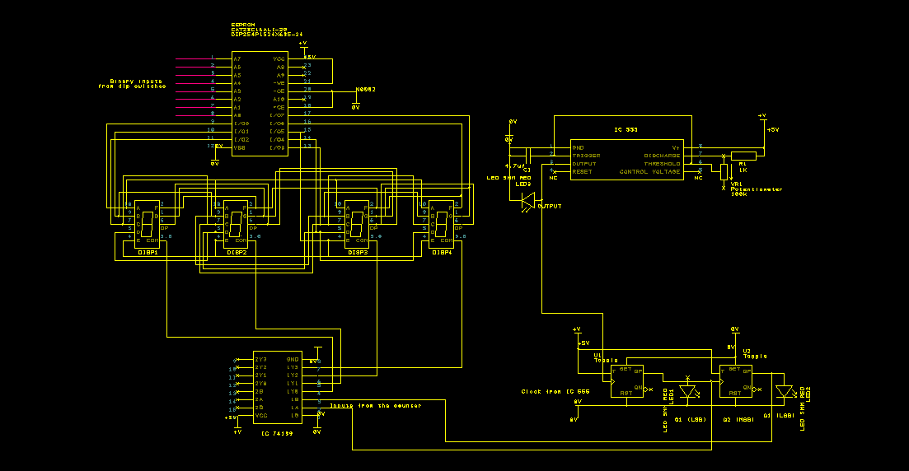 **Complete schematic diagram:** 

**Figure 4.31**

**CHAPTER 05**

**RESULT AND DISCUSSION**

The project was successfully completed before the due date. Each member of the group now has a very good understanding of how any display works which means we fulfilled the objective of our project.

Our basics on fundamental electronics has become stronger as we have implemented the concepts that we learnt in class on to a breadboard and practically made it work.

**GENERAL PICTURE OF THE PROJECT:**

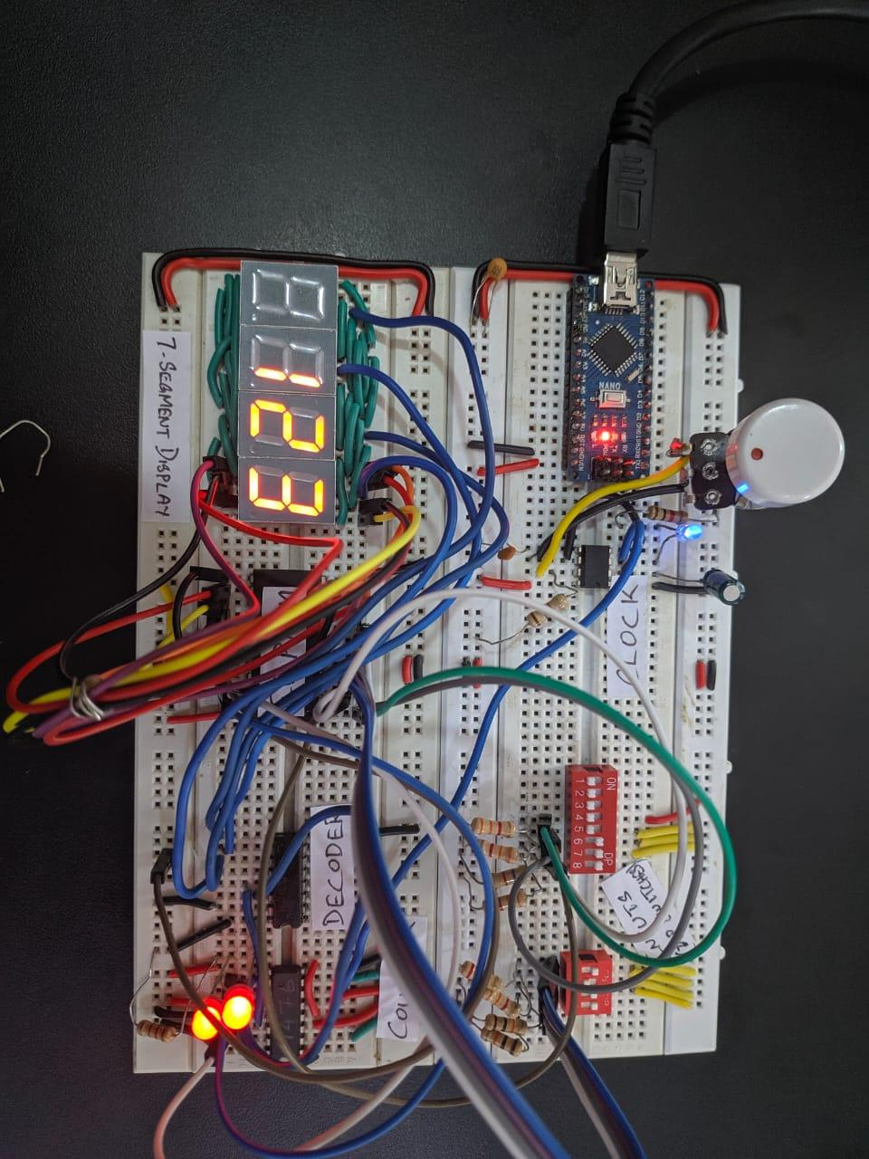

**Figure 5.0**

**CHAPTER 06**

**CONCLUSION AND FUTURE SCOPE**

The entire project was quite cost effective and well within our budget of ₹600. The total current consumption of the project is around 200mA.

We are very much satisfied with our results, but there is always room for improvement. Our future plans include, controlling the display wirelessly using Google Assistant and being able to scroll the data to display content that is longer than four characters.

**REFERENCES**

* [1] Interfacing a multiplexed seven segment display with 8086 by Md. Moyeed Abrar .
* [2] https.ben eater.com
* [ 3] Electronics Prescribed textbook 1st PUC and 2nd PUC by Department of Pre-University Education.
* [4] LM555 Timer datasheet .
* [5] Arduino projects to save the world .
* [6] AT28C16 Datasheet .